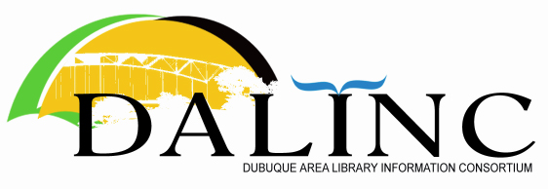

DALINC Business Meeting Minutes – Thursday, Sept. 23, 2021, 8:30 – Divine Word College

Present: Chris Doll (UD), Victor Lieberman (NICC), Katie Pauls (Maquoketa), Ericka Raber (DCSD), Nick Rossman (CSPL), Kristen Smith (Loras), Amanda Vazquez (DCLD), Shirley Vonderharr (Dyersville), Daniel Williams (DWC), Liz Winter (DWC)

Call to Order - Chris called the meeting to order at 8:33.

Approval of Agenda - Shirley motioned to approve the agenda. Kris seconded. Agenda was approved.

Past Minutes - Minutes for July 22, 2021 meeting will be reviewed for approval at next meeting.

Treasurer’s Report – accepted.

Introductions

Old Business
- Workshop Committee - Victor presented info

Panel discussion on public service is scheduled for Oct 13, 8:30-10:00 at NICC. John, Ericka, Katie, John N. presenting. Victor can arrange remote attendance via Zoom. No current restrictions on meetings or visitors at NICC. Discussion of publicity: committee would like to have something on DALINC website to share. Target audience: staff of our libraries and perhaps wider (training purpose).

Amanda will update website (including encouragement of registration). Victor will send out link when available. Chris will send out email to directors to invite staff.

Shirley moved to approve spending up to $50 per session on refreshments for workshops. Katie seconded. Approved.

B. Making DALINC meetings more accessible via Zoom – discussion. Katie offered to set up a recurring meeting via Zoom, and add others as a co-host, Discussion of purchasing a Zoom account for DALINC; possibly $80 (via Tech Soup) for DALINC—would allow use for workshop sessions, etc. Discussion of limiting hosting libraries to those that can support the hybrid in-person

Decision to do a trial run for Zoom meetings with Katie’s recurring link for meeting sites that have the capability.

New Business
DALINC Expectations - Discussion

Chris read from email provided in advance by John Berg and Sue Leibold.
History of DALINC – formed 25 years ago, mostly as a support group, working together on occasional large projects including group purchases. Under Joyce Meldrem’s (Loras) leadership, DALINC put together conference offerings; DALINC helped with ILA conference planning. This is more difficult now due to staffing difficulties.
Shirley shared experiences from her time on DALINC. Past work related to sharing catalog, grants, training. Group has evolved as needs have changed.

DALINC has helped members learn about politics and local challenges; helps members grow as managers/leaders. A virtual option would be appreciated for those who have difficulty attending due to staffing concerns.

Some suggestions for description of DALINC’s purpose/value: supporting library leadership with occasional programming; would be good to provide more opportunities for additional staff from member libraries to participate; organization evolves as needs of group change – there are times when we are able to do more collective projects, and times when we are not

Discussion of ways to connect staff across libraries so that they can share their own content and learn from each other. Listserv? Email?

Also discussed idea of having business meeting every other month via Zoom, and a more project-based in-person meeting on the off months.

Summary—continue meeting schedule as planned for now; continue providing opportunity to share; consider expanding opportunities to include staff; maybe return to having the host share something – consider for future;

Next meeting at UD

Adjournment - Amanda moved to adjourn; Katie seconded.

Minutes submitted by Ericka Raber, DALINC Secretary

