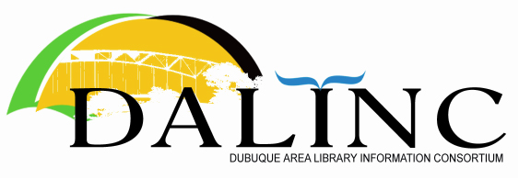 | MINUTES  Business Meeting  Univ. of Dubuque  18 Nov. 2021

Attendance: John Berg, Chris Doll, Victor Lieberman, Nick Rossman.
Remote: Kristin Smith, Sue Leibold.

The meeting was called to order at 8:30.

Moved & seconded to approve the agenda (Berg/Lieberman) passed.

Moved & seconded to approve the minutes of previous DALINC meeting of 23 Sept. 2021 (Lieberman/Berg) passed.

Treasurer’s report reviewed (informational).

OLD BUSINESS: Workshop Update

Report made by John & Victor about recent (first) DALINC workshop held at NICC Wednesday, 10/13. John summarized the format and discussion. 4 presenters were on site, and John lead & moderated the discussion remotely. Attendees were present in-person (5) and online (6). Remote attendees included 3 attendees at UD. Total attendees around 14. The topic of this discussion was “Reference Interviews & Customer Service.”

Update included a discussion about archiving workshops on our DALINC site to gradually accumulate professional development content. CE credit is available both for workshop attendees and (potentially) those who wish to view and submit a “Request for CE Credit Form” to the Iowa State Library.

Archive options include hosting content/links directly on the DALINC website, or perhaps setting up a YouTube channel.

The next workshop is set for Wednesday, December 8. Chris asked Victor what the status was on a moderator/host for the chosen for this discussion on “ILL; How is ILL handled locally; Rapid ILL? Iliad? etc.” Victor had been in touch with Eunice ​Riesberg (mid- to late-July) about possibly getting a presenter from the State Library on this topic, but nothing was concluded then (?).

Sue Leibold volunteered to moderate the upcoming workshop on ILL, and will coordinate with Chris to get information out to DALINC.

NEW BUSINESS: None.

DISCUSSION: Retaining Employees

At Platteville, a Public Services Librarian was hired and given more responsibilities, but no increase in salary. It was noted by several in the group that more attention has to be paid to making a pleasant work situation, where the library director does not have the authority/flexibility to increase pay or benefits. We can be more accommodating concerning vacation time/leave for instance.

We sometimes try to adapt the job to the employee, even within standard job classifications. This takes advantage of their skills, experience, and enthusiasm for certain tasks over others, within reason.

C-SPL has a staff committee that acknowledges life cycle events, work anniversaries, etc. On the one hand, this is an attempt to empower and provide an opportunity for staff to participate and share in some decisions and activities. Flip side is that it can also be additional duties, and do staff wish to take on these tasks as volunteers on top of the regular work.

Time off & leave is another area library directors can try to be flexible on, within reason. It was noted that a benefit isn’t much of a benefit if it is so restrictive it cannot be used when needed or convenient. But again, if everyone wants Friday afternoon off, it can be hard to keep our libraries open!

The meeting concluded with unminuted announcements.

The meeting adjourned at 10:20 AM.

