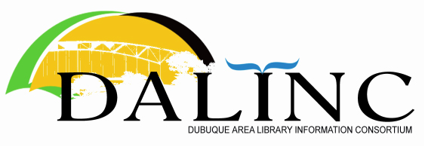 | Minutes  Thursday  Jan. 27, 2022  8:30 AM  Virtual:

- Chris called the meeting to order at 8:30

- Agenda was approved

- Nov. 18, 2021 meeting minutes were approved

- Treasurer’s Report was received. Susan will be submitting tax forms before April.

- Old Business
  - Workshop Update – recent ILL workshop was well received. About 12 people attended. Good information. Overview of ILL system.

- New Business
  - Next Workshop: Feb 9, 2022, 8:30-10:00, online
Topic: Privacy and confidentiality
Presenters: Becky Heil (State Library), Sarah Slaughter (UD), and Joe Letriz (UD)

- Discussion
  - Diversity and Inclusion in the library. Selected takeaway points:
    - Helpful to use “we” language when discussing policies with board, admin, and staff
    - Diversity audits – some completed with vendor support at a cost (e.g. Ingram)
    - Patron request for purchase
    - Self-censorship
    - Diversity of staff

Announcements (unminuted)

 | January | March | May | July | Sept. | Nov.
2022 | Virtual | Emmaus? | UW - Platteville | Galena | JKPL | State Library of Iowa

Official meeting adjourned at 9:40. Next meeting Mar 24, 8:30-10:00, Emmaus.

Submitted by Ericka Raber

