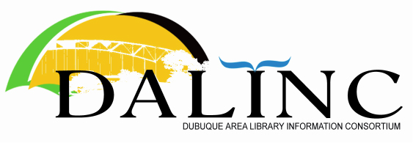 | Minutes  Thursday  May 26, 2022  8:30 AM

Attendance: John Berg, Chris Doll (President), Susan Ebertz, Victor Lieberman, Kristen Smith, Ericka Raber, Nick Rossman, Amanda Vazquez, Shirley Vonderhaar

Guest: Eunice Riesberg from the State Library
Where: NICC in person; and via Zoom

- Chris called the meeting to order

- Agenda was approved

- March 24, 2022 meeting minutes were approved

- Treasurer’s Report was received

- Old Business
  - Workshop Update – April 13 topic—Intellectual Freedom – Amanda served as moderator. Small audience, but well-received. DALINC will continue discussion of offering future workshops.

- New Business
  - Next year’s leadership team – Nick Rossman was elected President; Kristen Smith was elected as Vice-President; Victor Lieberman was elected as Secretary; Susan Ebertz was elected as Treasurer
  - Eunice Riesberg – suggested newsletter Monday Morning Eye Opener; contracts for FirstSearch and CatExpress good through end of 2023, and then will be reviewed; some positions being reviewed after retirements and staffing shifts; working on focus group for social workers; discussion of ARPA grants; discussion of Mobius and IPAL ILL delivery--Kristen mentioned challenges with using this service at Loras

Meeting ended at 8:53.

- Announcements (unminuted)

Upcoming meetings:
 | July | Sept. | Nov.
2022 | Galena | JKPL | State Library of Iowa

