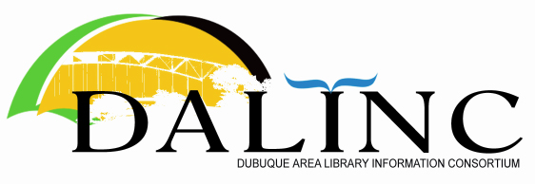 | Agenda  Thursday  July, 28, 2022  8:30 AM  Virtual:

Topic: DALINC Business Meeting
Where: Asbury Branch, Dubuque County Library District
5290 Grand Meadow Drive, Asbury, IA 52002
or
Virtual: https://us06web.zoom.us/j/85007795742
Meeting ID: 850 0779 5742
Dial by your location
+1 312 626 6799 US (Chicago)
877 853 5247 US Toll-free
888 788 0099 US Toll-free

Present: Nick Rossman (President); Andrew Fuerste-Henry (DCLD); Victor Lieberman (NICC); Amanda Vazquez (DCLD).
Remote: John Berg (UW-P); Becky Canovan (UD); Kelsey Metcalf (DCSD); Kristen Smith (8:48 am) (Loras)

- Call to Order
The meeting was called to order at 8:34 by President Rossman

- Approval of Agenda
Moved & Seconded (Vazquez/Lieberman). Approved.

- Approval of May 26, 2022 meeting minutes
Moved & Seconded (Berg/Vazquez). Approved.

- Treasurer’s Report
Distributed by email. Received & filed.
2 items: 2022/23 Membership Renewals & Treasurer’s Report 28 July 2022.
Brief discussion of membership scofflaws.

- Old Business
  - Workshop update/discussion
Vazquez reviewed 4 Workshops held last year 2021/22. Recordings of each workshop (Reference, ILL, Intellectual Freedom, & Privacy) are available on the DALINC website “Workshops” tab (the 4th to be posted shortly). Because speaker permission/release was not secured in advance, workshops will not be made available on YouTube. DALINC also links to the State Library of Iowa’s External CE Credit form as a convenience for those wishing to apply for it.

It was agreed by those present that these workshops went well, and were worthwhile for DALINC to continue holding.

The workshop planning committee (Vazquez, Lieberman, & Rossman) will meet to propose a schedule of 4 new workshops for the upcoming academic year. DALINC members are encouraged to suggest topics they feel would be of interest to our membership and the local library community more generally. The committee will present it’s proposed schedule and topics to DALINC at either our next business meeting in September or in advance by email.

- New Business
  - Review of meeting schedule
Rossman reviewed the DALINC meeting scheduled distributed earlier by email. He noted that an email system problem prevented Galena PL from confirming their hosting for July, obliging us to change locations for this month.

Nick will reach out to current members to learn if they can host business meetings in the upcoming calendar year so this schedule can be set (Jan., Mar., May, Jul., Sept., & Nov.).

Meeting concluded at 9:33 am.
Submitted by Victor Lieberman, DALINC Secretary

- Announcements (unminuted)

 | July | Sept. | Nov.
2022 | Galena  Dubuque County (Asbury) | JKPL | State Library of Iowa

